**FINAL PORTFOLIO**

TEAM 4

**CleckShopHub**

**Team Members:**

**Abhisek Poudel**

**Amulya Shrestha 77356835**

**Biliyas Maharjan**

**Biraj Shrestha**

**Shasank Shrestha**

**Soya Shrestha**

**Susan Bhandari**

**TABLE OF CONTENS**

5. Frequently Asked Questions pg190

5.Frequently Asked Questions

i. What is cleckhuddersfaxfoodhub.com?

Cleckhuddersfaxfoodhub.com is a collaborative venture of a group of local grocery stores from Cleckhuddersfax with a motive to provide a

hassle free online grocery store.

i. Why use our service?

In today’s hustle and bustle, people are busy with their life. We aim to make grocery shopping convenient and quick with options for online as well as cash transactions

ii. Can I return an item?

As we sell fresh products that are subjected to quick decay, we do not accept returns.

iii. Why use our service?

As we sell fresh products that are subjected to quick decay, we do not accept returns. However, if you're not satisfied with the product, you can always post a review!

# Project Planning

## d. Skill Audit

### I. Team Skills Audit

### 

### II. Individual Skills Audit



Figure : Abhishek Poudel Individual Skill Audit



Figure : Amulya Shrestha Individual Skill Audit

## e. Project Management

### I. Gantt Chart

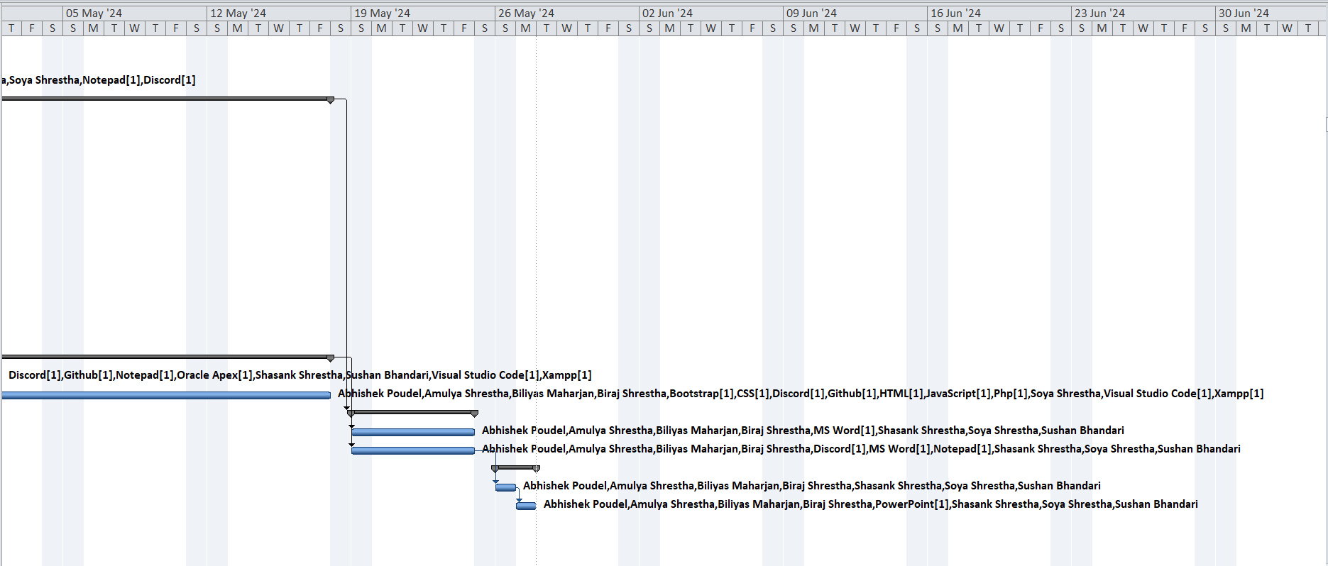

### II. Task Sheet

### III. Timeline

### IV. Resource Sheet

### V. Calendar

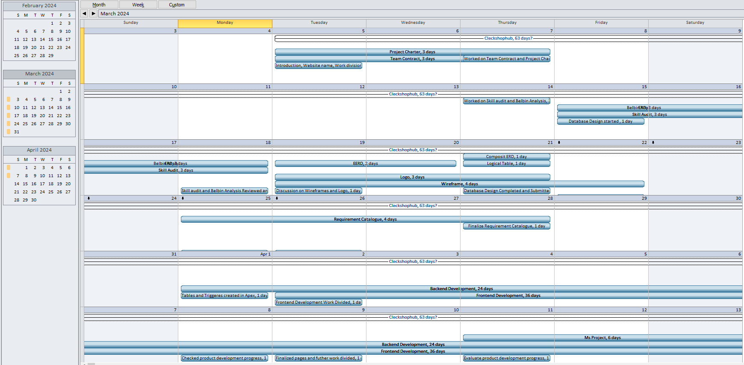

### VII. Change in Working Time

## f. Communication and collaboration tools

### I. Discord

### II. Github

## g. Team Meetings

**Virtual Meeting:**

**Day 1(03/05/24): (Online)**

**Objectives:**

* Introduction of the team members
* Division of work among the team members.
* Website name decided (i.e. CleckShopHub).

**Day 2 (03/07/24): (Online)**

**Objectives:**

* Began with the contract work and project charter.
* Deliberation and agreement on the project contract.

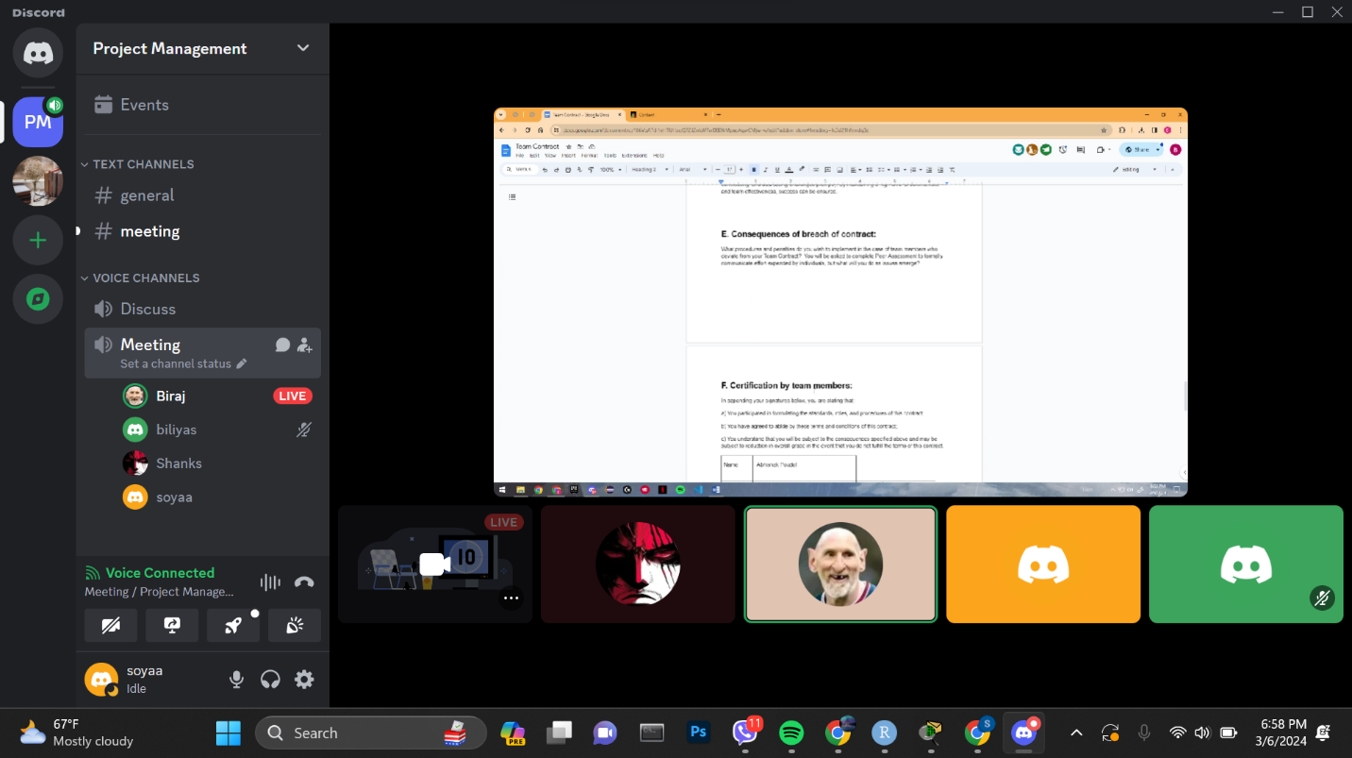

**Day 3 (03/14/24): (Online)**

**Objectives:**

* Reflected upon individual strengths and weaknesses for Skill audit.
* Decided and discussed suitable Belbin roles for each member.

**Day 4(03/15/24): (Online)**

**Objectives:**

* Prepared ERD diagram to design database models used in our site.

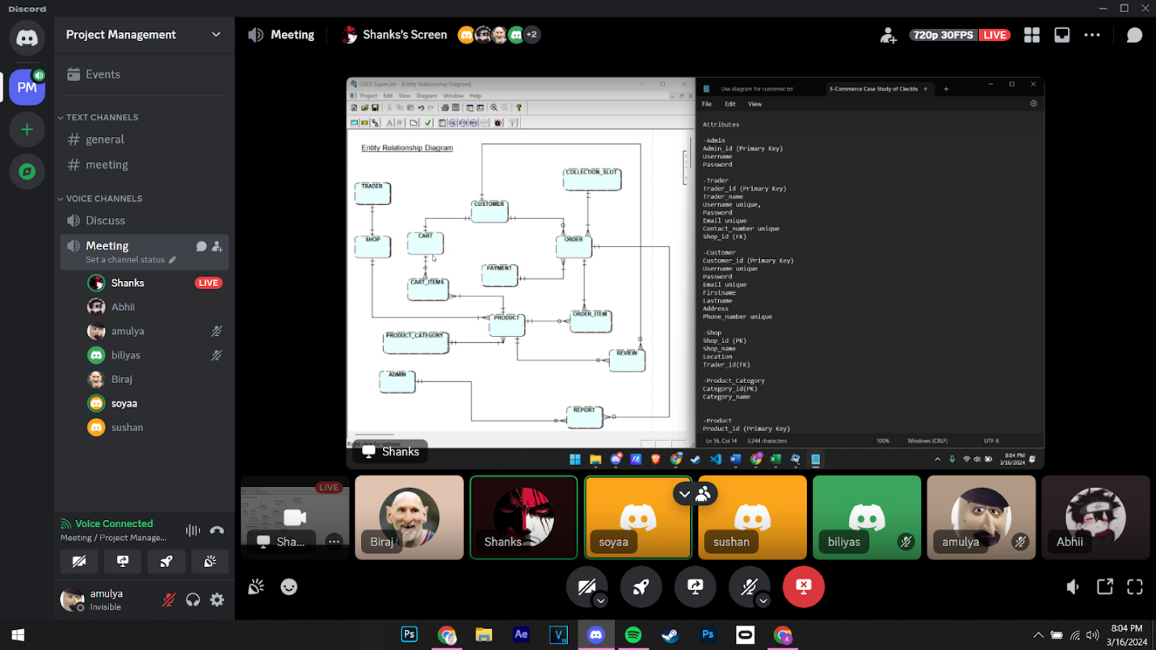

**Day 5(03/18/24): (Physical)**

**Objectives:**

* Began creating wireframes for web pages using Figma.
* Continued working on the ERD.
* Discussion on the logo.
* Started designing a website logo
* Commenced work on the wireframe.

**Day 6(03/19/24): (Physical)**

**Objectives:**

* Made various versions of logo

**Day 7(03/21/24): (Online)**

**Objectives:**

* EERD/ERD/Final Composite & Decomposition ERD/ Logical Table discussion and submission.
* Continued making wireframes.

**Day 8(03/22/24):**

**Objectives:**

* Started working on Use Case Diagram
* Continued Wireframe.
* Started working on use case diagram
* Discussion on Functional and Non-Functional Requirements.

**Day 9(03/25/24):**

**Objectives:**

* Worked on Functional and non-functional requirements

**Day 10(03/26/24): (Online)**

**Objectives:**

* Finalizing Use Case Diagram
* Discussion on Functional and Non-Functional Requirements.

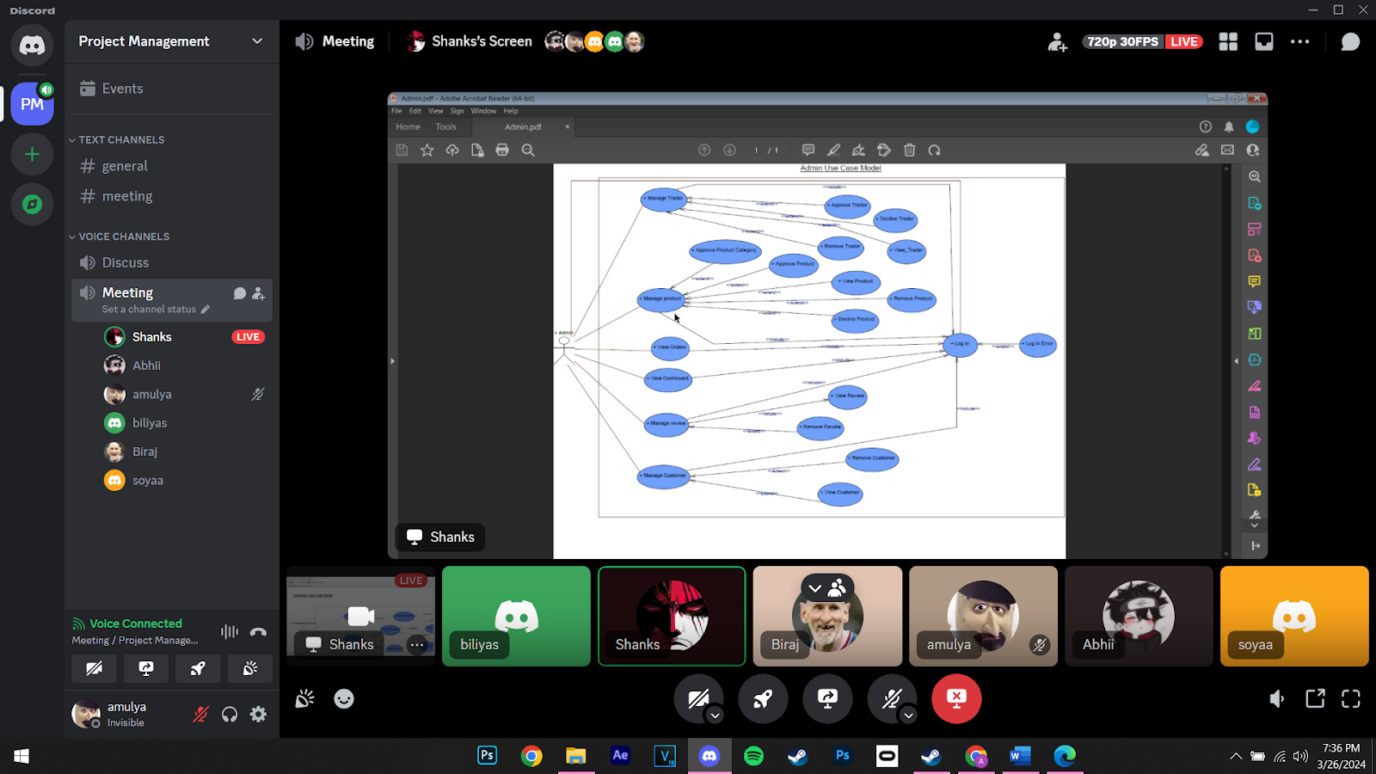

**Day 11(03/28/24): (Online)**

**Objectives:**

* Submission of Use case diagram and functional and non-functional requirements.

**Day 12(04/01/24): (Online)**

**Objectives:**

* Submission of Use case diagram and functional and non-functional requirements.
* Commenced making tables and triggers in Apex

**Day 13(04/02/24): (Physical)**

**Objectives:**

* Discussion on how to further proceed on the project
* Division on individual work (HTML, CSS)
* Table created in the database

**Day 14(04/08/24): (Physical)**

**Objectives:**

* Checked on individual progress.
* Discussion on what changes should be made in HTML and CSS
* Triggers were created in the database

**Day 15(04/09/24): (Physical)**

**Objectives:**

* Finalized the HTML and CSS work and decided how to combine individual works.
* Individual work was pushed, creating each folder in the GIT hub

**Day 16(04/11/24): (Physical)**

**Objectives:**

* Discussion on work progress and how to further proceed with the project

**Day 17(04/15/24): (Online)**

**Objectives:**

* Started maintaining schedules on MS Project

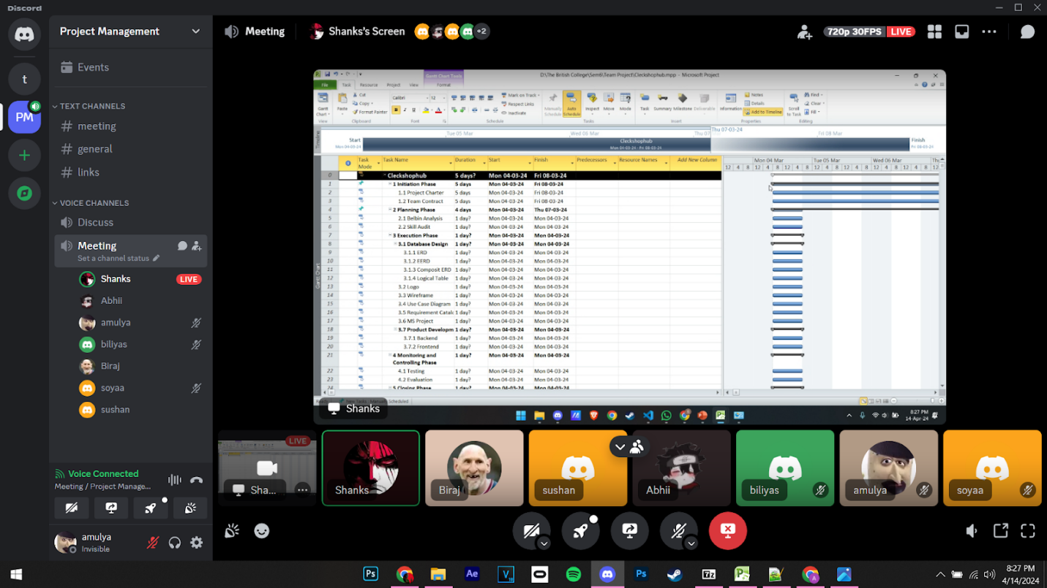

**Day 18(04/18/24): (Online)**

**Objectives:**

* Finalized ms project
* Made necessary changes in slides and word file for wip

**Day 19(04/19/24): (Physical)**

**Objectives:**

* Finalized ms project
* Made necessary changes in slides and word file for wip

# 2. Product Designing

# a. EERD

## I. ERD

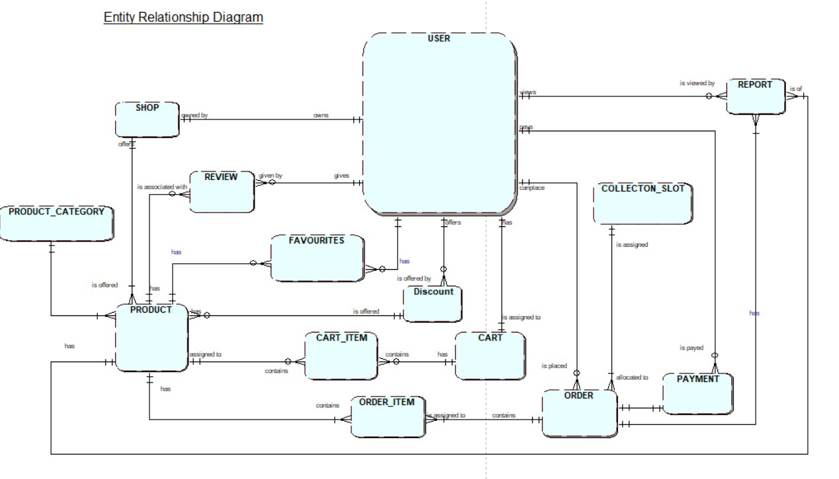

## II. EERD

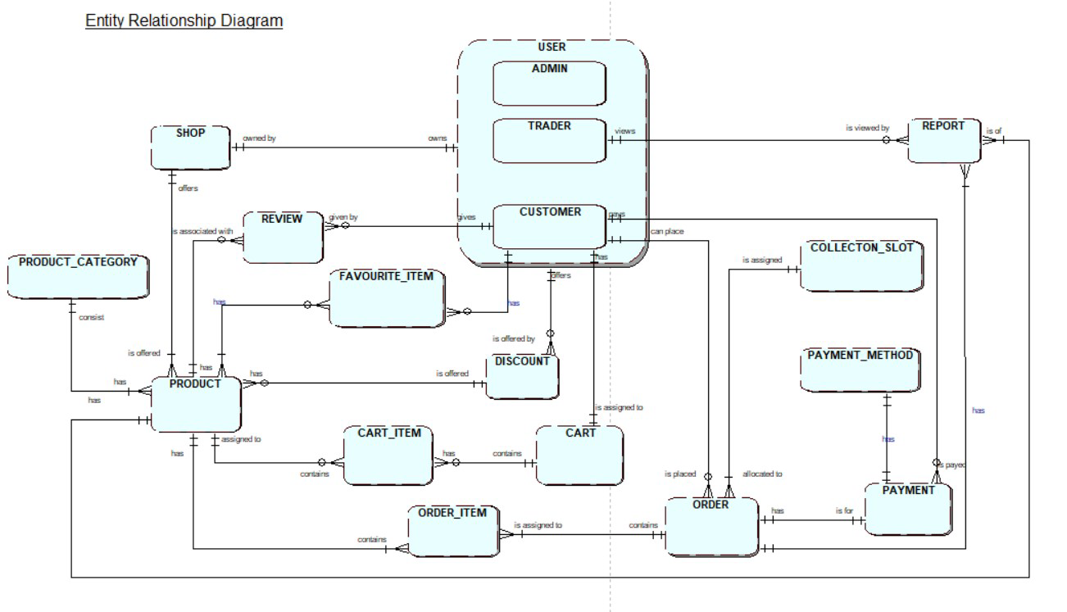

## III. Composite EERD

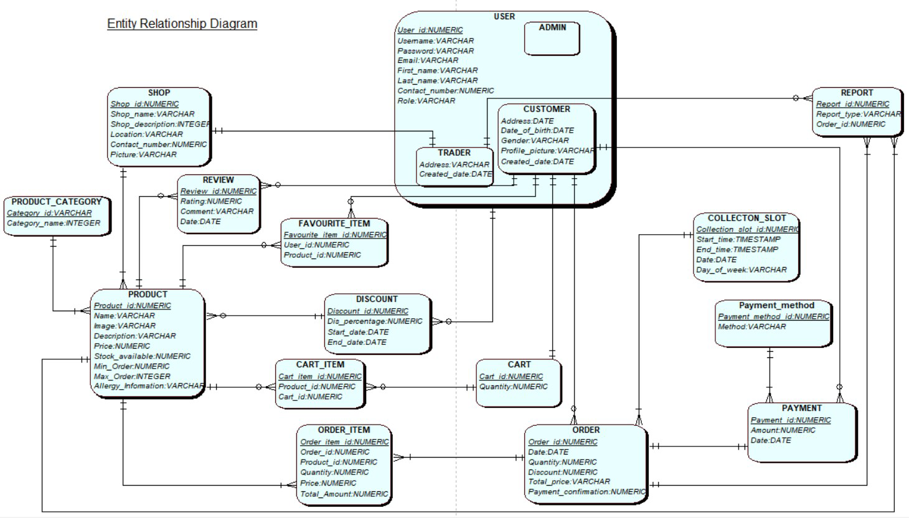

## IV.Logical Table

1. USER(**User_id**, Username, Password, Email, First_name, Last_name, Contact_number, Role)
2. ADMIN(***User_id***)
3. TRADER(***User_id***, Address, Created_date, Last_loggedin_date)
4. CUSTOMER(***User_id,*** Address, Date_of_birth, Gender, Profile_picture, Created_date, Last_loggedin_date)
5. SHOP(**Shop_id**, Shop_name, Location,Shop_Description, Picture, Contact_number, *User_id*)
6. PRODUCT(**Product_id**, Name, Image, Description, Price, Stock_Available, Min_Order, Max_Order, Allergy_Information, *Shop_id, Category_id,Discount_id)*
7. PRODUCT_CATEGORY(**Category_id**, Category_name)
8. REVIEW(**Review_id**, Rating, Comment, Date, *Product_id, User_id)*
9. FAVOURITE_ITEM(**Favourite_item_id**, *User_id*, *Product_id*)
10. DISCOUNT(**Discount_id**, Dis_percentage, Start_data, End_date, *User_id*)
11. CART(**Cart_id**, Quantity, *User_id*)
12. CART_ITEM(**Cart_item_id**, *Cart_id, Product_id)*
13. ORDER(**Order_id**, Date, Quantity, Discount, Total_price, Payment_confirmation, *User_id, Collection_Slot_id)*
14. ORDER_ITEM(**Order_item_id**, Quantity, Price, Discount, Total_Amount, *Order_id, Product_id*)
15. COLLECTION_SLOT(**Collection_slot_id**, Start_time, End_time, Date, Day_of_week)
16. PAYMENT(**Payment_id**, Amount, Date, *User_id, Order_id, Payment_method_id*)
17. PAYMENT_METHOD(**Payment_method_id**, Method)
18. REPORT(**Report_id**, Date, Report_type, *User_id, Order_id, Product_id)*

## b. Use Case Diagram

### I. Overall Use Case Diagram

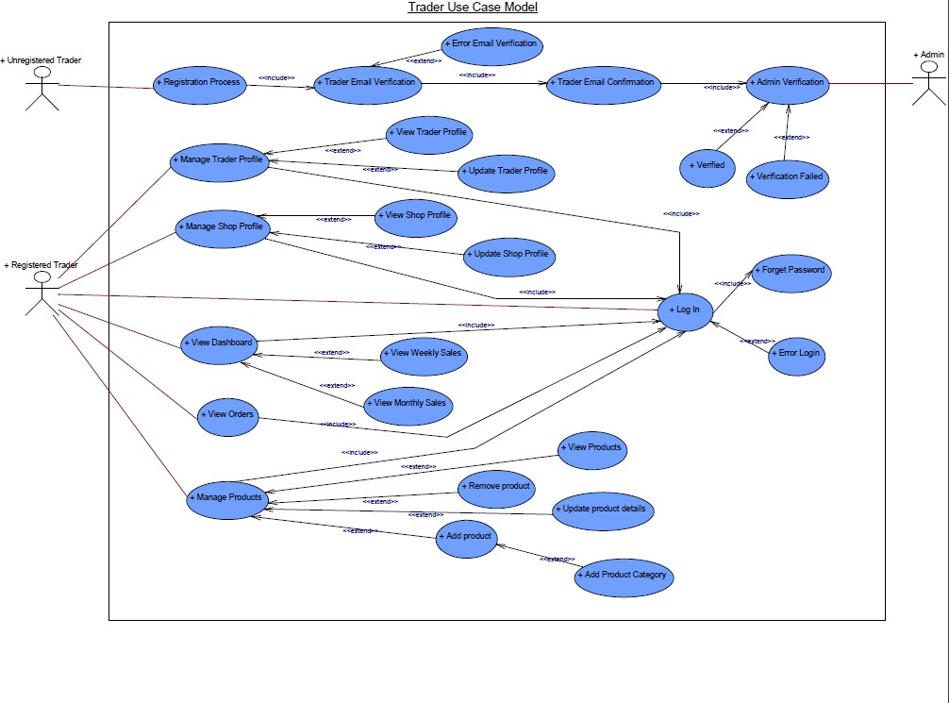

Figure : Overall Use Case Diagram

### II. Customer Use Case Diagram

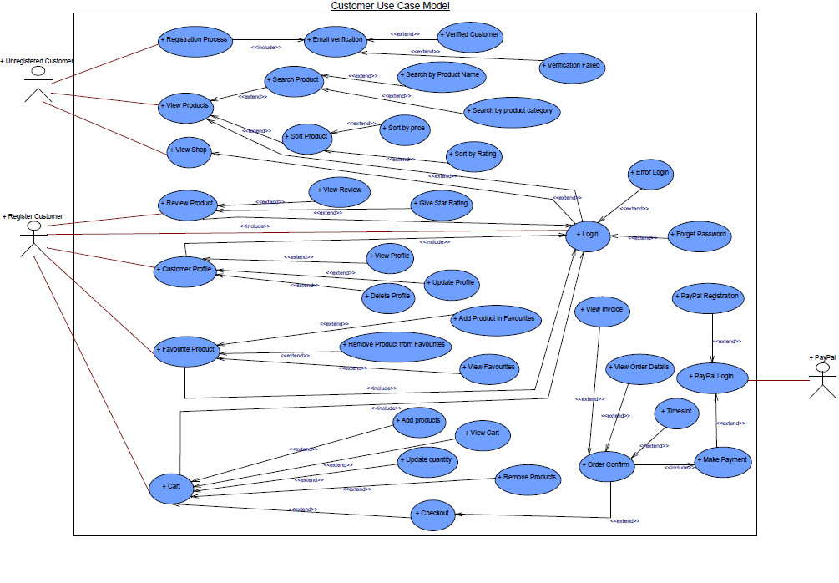

Figure : Customer Use Case Diagram

### III. Trader Use Case Diagram

### IV.Admin Use Case Diagram

## c.Requirement Catalogue

### I. Functional Requirement

* A: Product

|  |  |  |
| --- | --- | --- |
| **Requirement ID** | **Description** | **MoSCoW** |
| **A1** | **All products need details.** |  |
| A1-01 | Each product should have their name, price, stock information, minimum order, and maximum order. | M |
| A1-02 | Products should be associated with a specific shop. | M |
| A1-03 | Product should have a product category. | M |
| A1-04 | Product should have image and allergy information. | S |
| A1-05 | Product should display average rating and review count. | S |
| A1-06 | Products can have discount applied to them. | C |
| **A2** | **An interface to navigate product and shop.** |  |
| A2-01 | Users should be able to see shop details like name, location, description etc. | M |
| A2-02 | Users should be able to search products by product name or product category. | M |
| A2-03 | Users should be able to search for products by shop. | S |
| A2-04 | Users should be able to filter products based on price and rating. | S |
| **A3** | **An interface to add products in cart and wish list.** |  |
| A3-01 | Users should be logged in to add products to their cart. | M |
| A3-02 | Users should be able to add up to 20 different items in the cart at a time. | M |
| A3-03 | Users should be able to view items in their cart. | M |
| A3-04 | Users should be able to add/ remove product from their wish list or favorites list. | S |
| A3-05 | Users should be able to increase or decrease the quantity of products from the cart. | C |
| **A4** | **An interface for review and rating for product.** |  |
| A4-01 | Users should be able to leave a textual review of the product. | S |
| A4-02 | Users should be able to give star ratings to a product. | S |
| A4-03 | Products should have a date of reviewed. | C |

* B: Customer

|  |  |  |
| --- | --- | --- |
| **Requirement ID** | **Description** | **MoSCoW** |
| **B1** | **An interface to register for new user.** |  |
| B1-01 | User should provide all required details i.e. name, address, contact number etc. to register. | M |
| B1-02 | Email verification should be required during registration. | M |
| B1-03 | Password should be 8 to 32 characters long. | S |
| B1-04 | Password should contain an uppercase, number and a special character. | C |
| **B2** | **An interface for user login.** |  |
| B2-01 | User should be able to log in using their registered credentials. | M |
| B2-02 | User should be able to reset their password via web interface. | S |
| B2-03 | User should be able to reset their password via email verification if he/she forgets. | C |
| **B3** | **An interface to view and update profile.** |  |
| B3-01 | User should be able to view and update their profile information. | M |
| B3-02 | User should be able to change their password. | S |
| B3-03 | User should be able to upload or remove profile picture. | C |
| **B4** | **Customer should be able to view product.** |  |
| B4-01 | Customer should be able to search and browse products. | M |
| B4-02 | Customers should be able to view product details. | M |
| B4-03 | Customer should be able to sort and filter products. | S |
| B4-04 | Customers should be able to view product review and ratings | S |
| B4-05 | Customers should be able to view related products. | S |
| B4-06 | Customers should be able to view product availability. | C |
| **B5** | **Customer has access to cart.** |  |
| B5-01 | Customer should be logged in to access cart. | M |
| B5-02 | Customers should be able to view the total cost of items in their cart. | M |
| B5-03 | Customers should be able to remove all the products from cart using “Clear All” button. | S |
| B5-04 | Customers should be able to increase or decrease the quantity of product in the cart. | S |
| B5-05 | Customer should be able to save their cart for later. | C |
| **B6** | **Customer has wish list.** |  |
| B6-01 | Customers can add or remove product from their wish list. | C |
| **B7** | **An interface to place order.** |  |
| B7-01 | Customer should be able to select a collection time slot while placing order. | M |
| B7-02 | Customer should be able to pay through PayPal. | M |
| B7-03 | Customer should get a notification about order confirmation. | S |
| B7-04 | Customer should be able to cancel their order. | C |
| **B8** | **An interface to review product.** |  |
| B8-01 | Customer should be able to leave a review and star rating on the product they have purchased. | M |
| B8-02 | Customer should be able to edit their review and ratings. | C |
| **B9** | **An interface to view order details.** |  |
| B9-01 | Customer should be able to view their order details. | M |
| B9-02 | Customer should be able to view their order history. | C |

C: Trader

|  |  |  |
| --- | --- | --- |
| **Requirement ID** | **Description** | **MoSCoW** |
| **C1** | **An interface for trader registration and login.** |  |
| C1-01 | Trader should be able to register with their shop information. | M |
| C1-02 | Traders should be able to log in using their registered credentials. | M |
| C1-03 | Traders should be able to reset their passwords via email verification if they forget their passwords. | S |
| C1-04 | The registration and login forms should have proper validations. | C |
| C2 | **An interface to view and update profile.** |  |
| C2-01 | Traders should be able to view and update their profile via web interface. | M |
| C2-02 | Traders can view and update their shop information, including descriptions and contact details. | M |
| C2-03 | Traders should be able to change their passwords. | S |
| **C3** | **Trader can manage product and shop.** |  |
| C3-01 | Traders should be able to add new products to their shop. | M |
| C3-02 | Traders should be able to update stock information of the product. | M |
| C3-03 | Traders should be able to update shop information. | M |
| C3-04 | Traders should be able to remove the product. | S |
| C3-05 | Traders should be able to set discounts on their products. | C |
| **C4** | **Access to dashboard and reports.** |  |
| C4-01 | Traders should be able to access the dashboard via website or apex. | M |
| C4-02 | Traders can view details of daily orders. | M |
| C4-03 | Traders can view daily, weekly, and monthly reports. | M |
| C4-04 | Traders can view weekly financial reports. | S |
| C4-05 | Traders can filter reports based on date. | S |
| C4-06 | Traders should be able to export reports in various formats. | C |

* D: Management

|  |  |  |
| --- | --- | --- |
| **Requirement ID** | **Description** | **MoSCoW** |
| **D1** | **An apex login interface.** |  |
| D1-01 | The administrator should be able to log in via both website and apex. | M |
| **D2** | **Manage trader and user.** |  |
| D2-01 | Admin should be able to view traders. | M |
| D2-02 | Admin should be able to view customers. | M |
| D2-03 | Admin should be able to approve or decline a trader register request. | M |
| D2-04 | Admin should be able to remove a trader or customer account. | M |
| D2-05 | Admin should be able to remove a review written by a user. | M |
| D2-06 | Admin should be able to send notifications to traders and users. | C |
| **D3** | **Management reports** |  |
| D3-01 | Admin should have access to various management reports and analytics. | M |
| **D4** | **Payment** |  |
| D4-01 | The system should support integration with payment gateways like PayPal and Stripe. | C |

1. Non-Functional Requirement

* E: Non-Functional

|  |  |
| --- | --- |
| **Requirement ID** | **Description** |
| E1 | The website should respond within an acceptable timeframe to user actions. |
| E2 | The website should be able to handle increasing loads of users and data without sacrificing performance. |
| E3 | User’s accounts should be securely stored and protected against unauthorized access or data breaches. |
| E4 | Properly authenticating users and authorizing access to different parts of the website based on their roles and permission. |
| E5 | Encryption protocols to protect sensitive data such as payment information and personal details. |
| E6 | Websites should run smoothly across different devices and screen sizes. |
| E7 | Reliable backup and recovery procedures to protect against data loss and maintain operations during system failures. |
| E8 | Ensure users to leave feedback, ratings and reviews for products and services. |
| E9 | Recommend products and contents based on individual user preferences, browsing and payment history. |

# D. Logo Design

# E.Wireframe

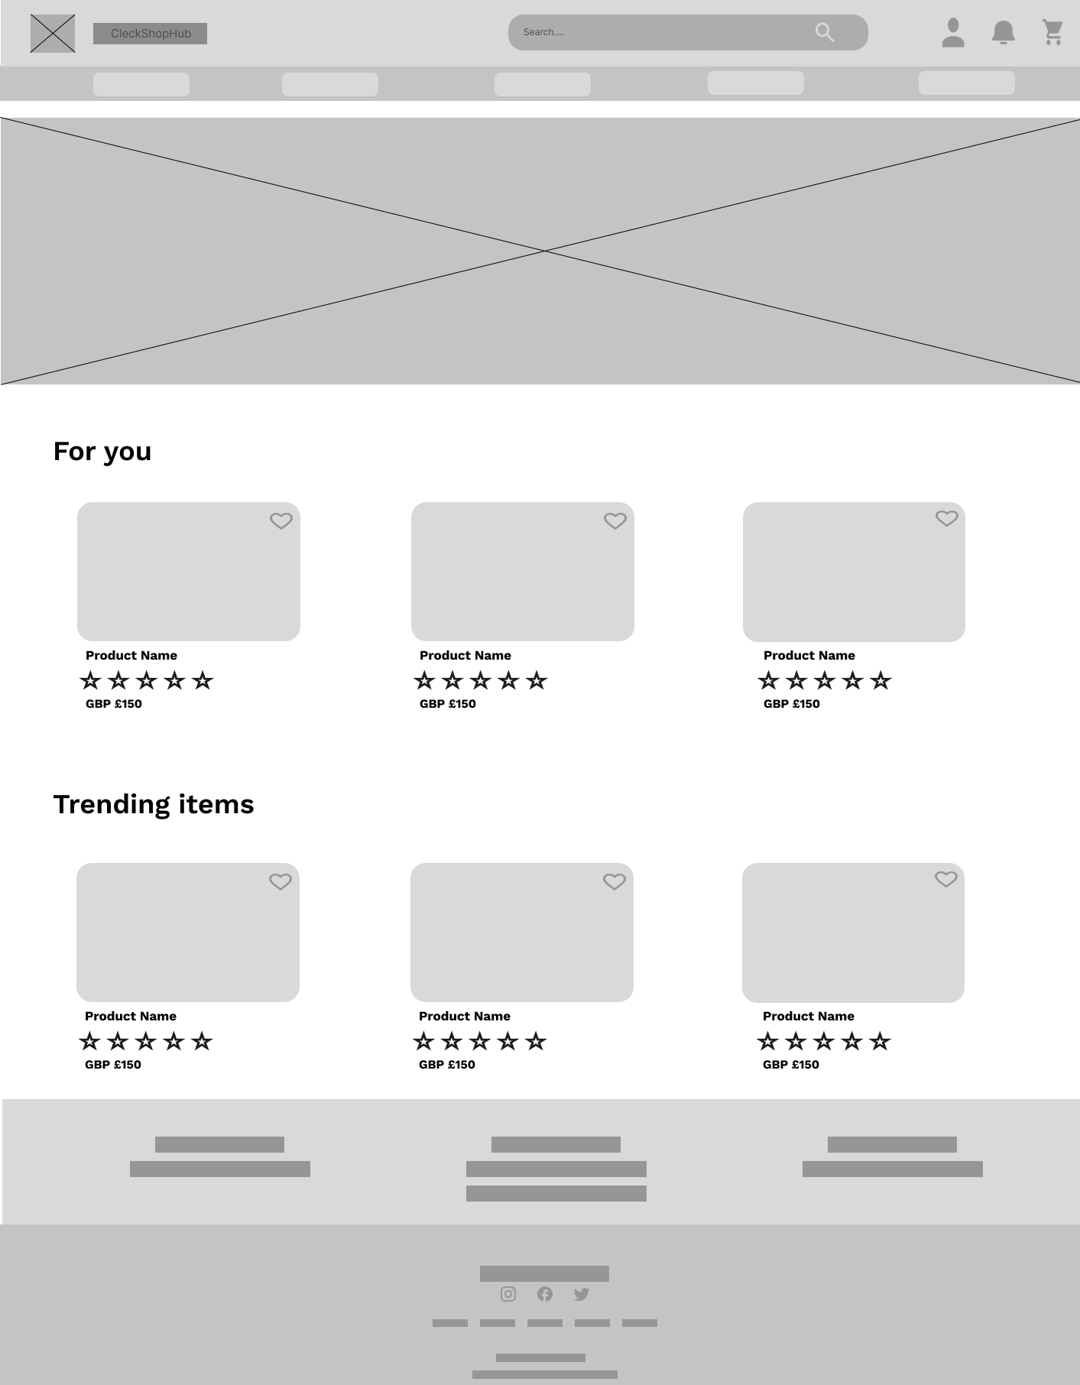

Figure :Home Page Wireframe

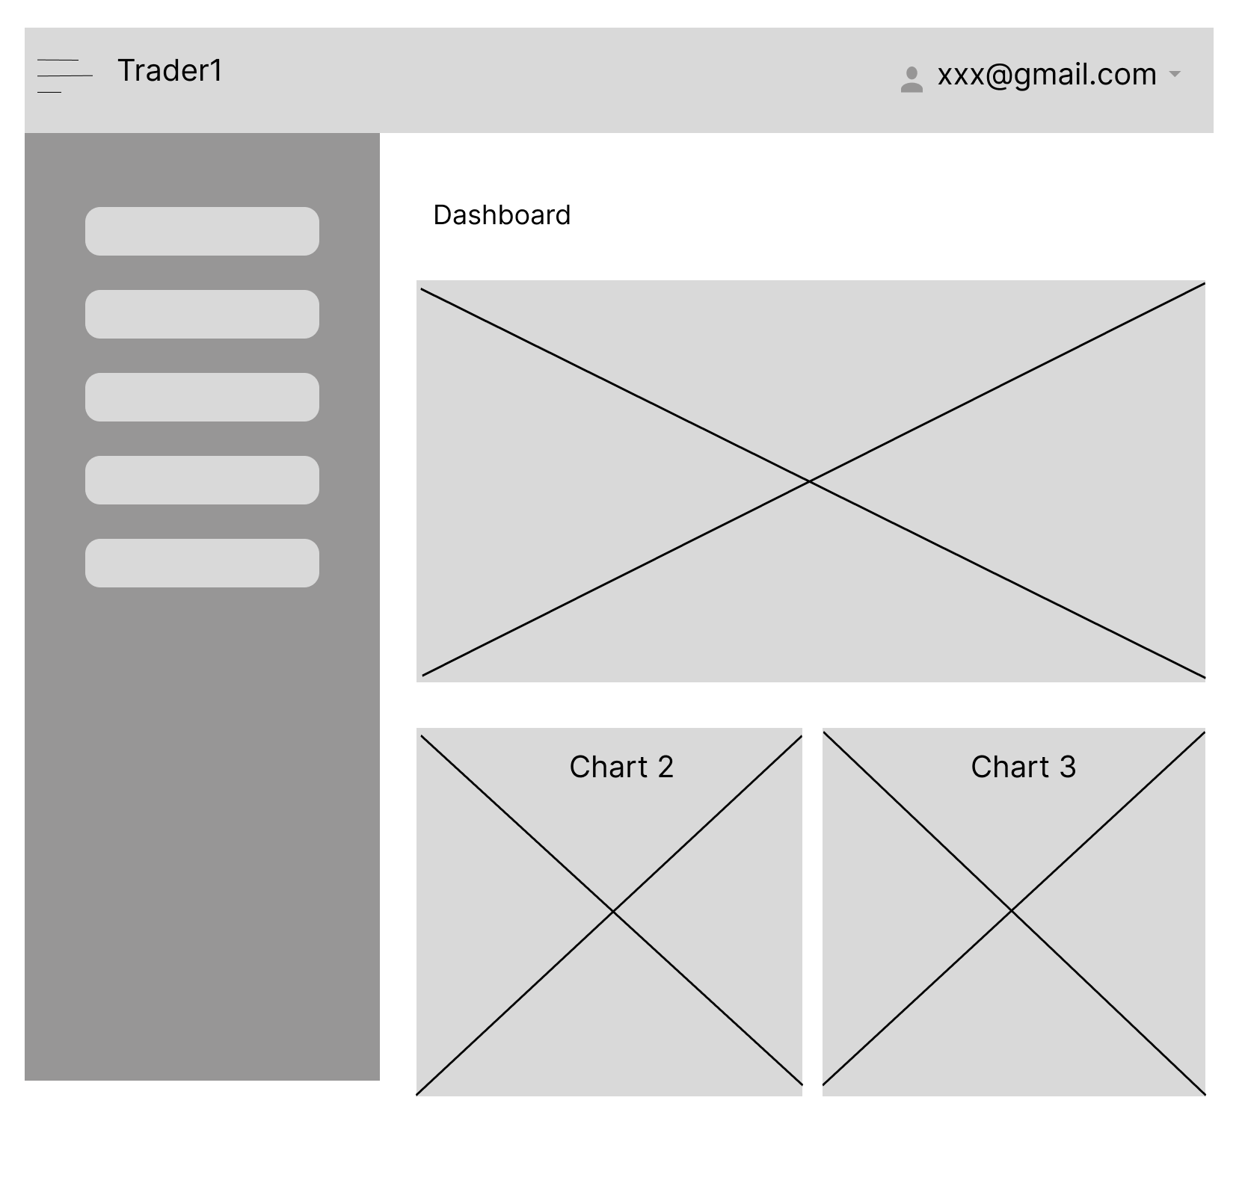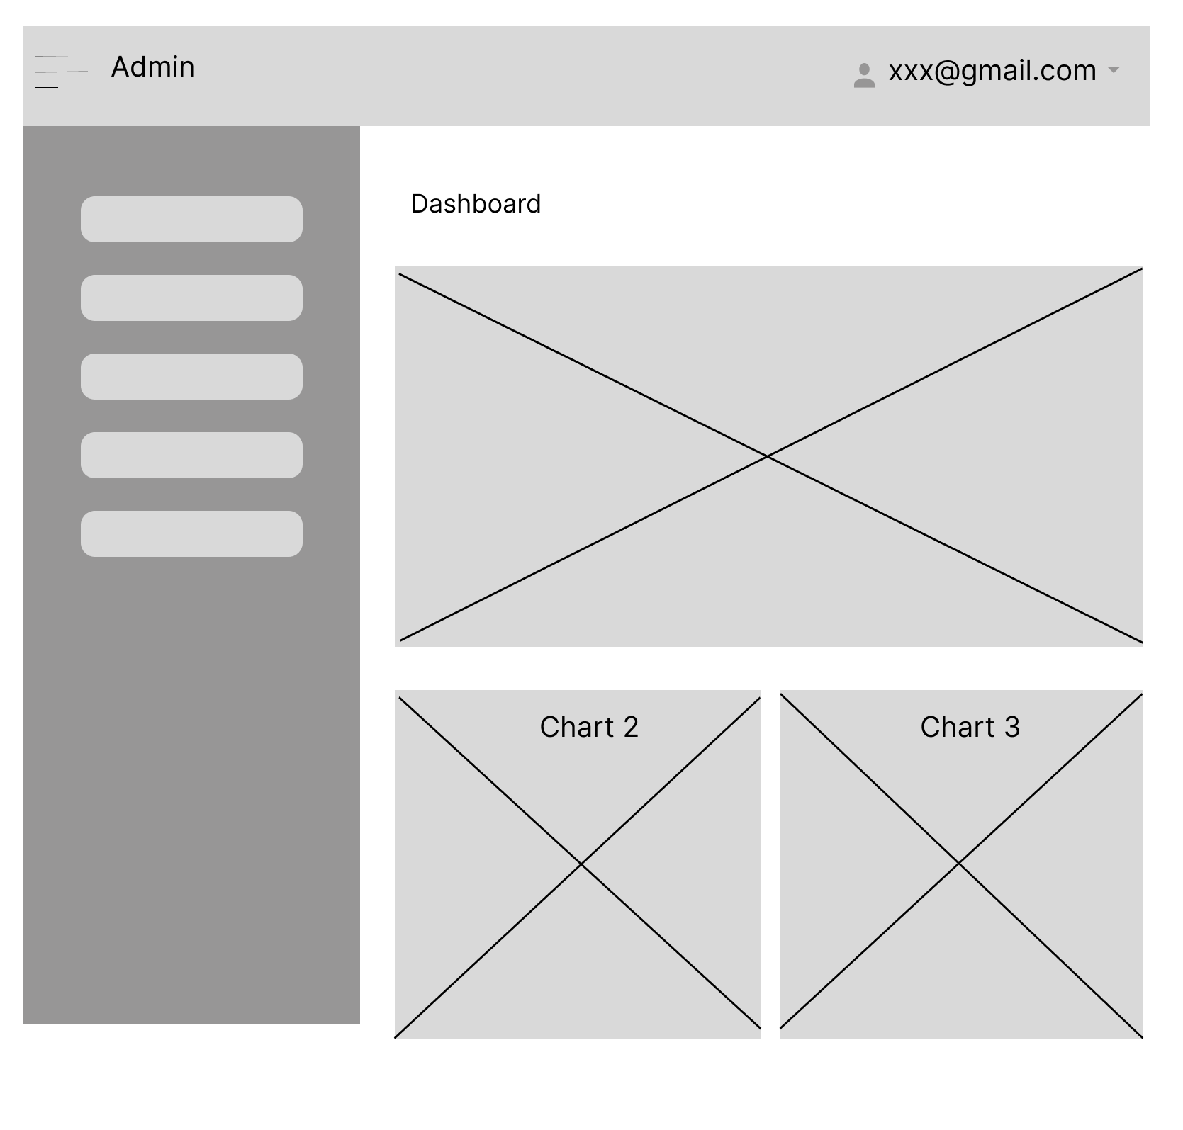

Figure : Admin CRUD

Figure : Trader CRUD

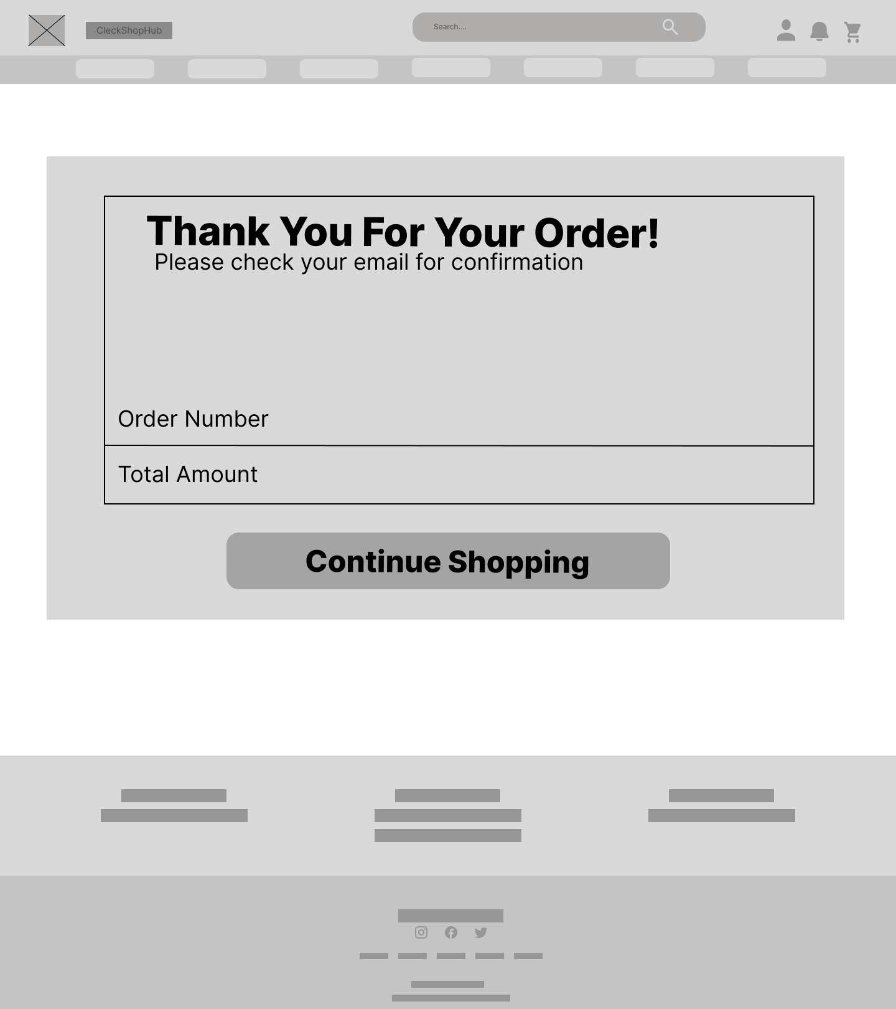

Figure : Invoice

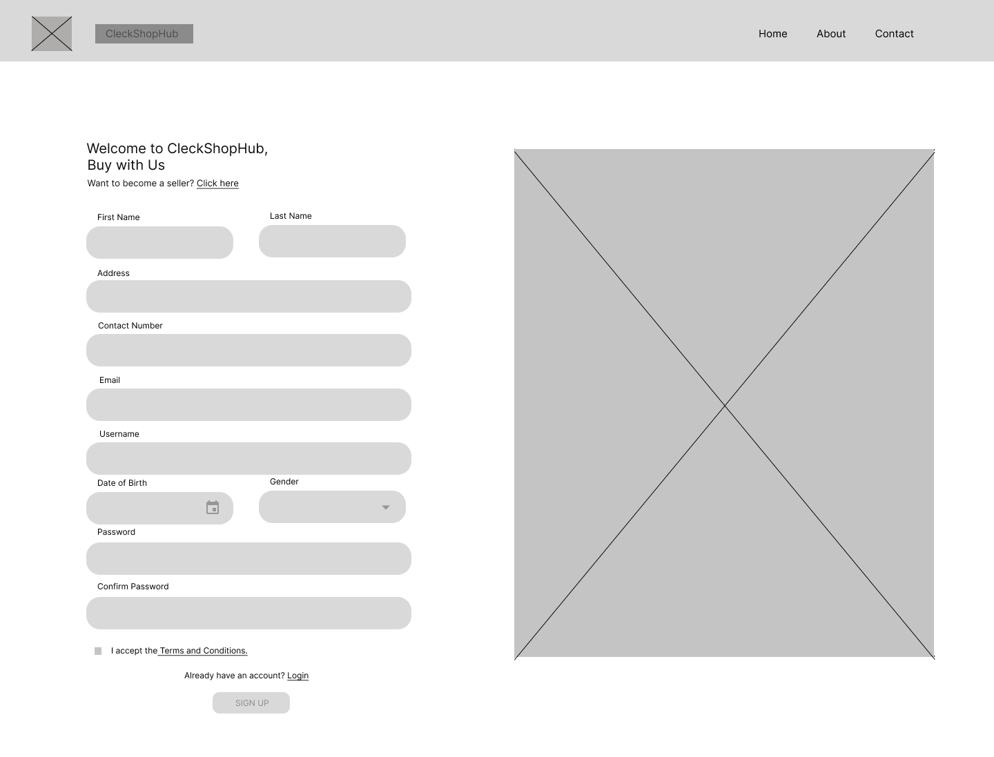

Figure : Register

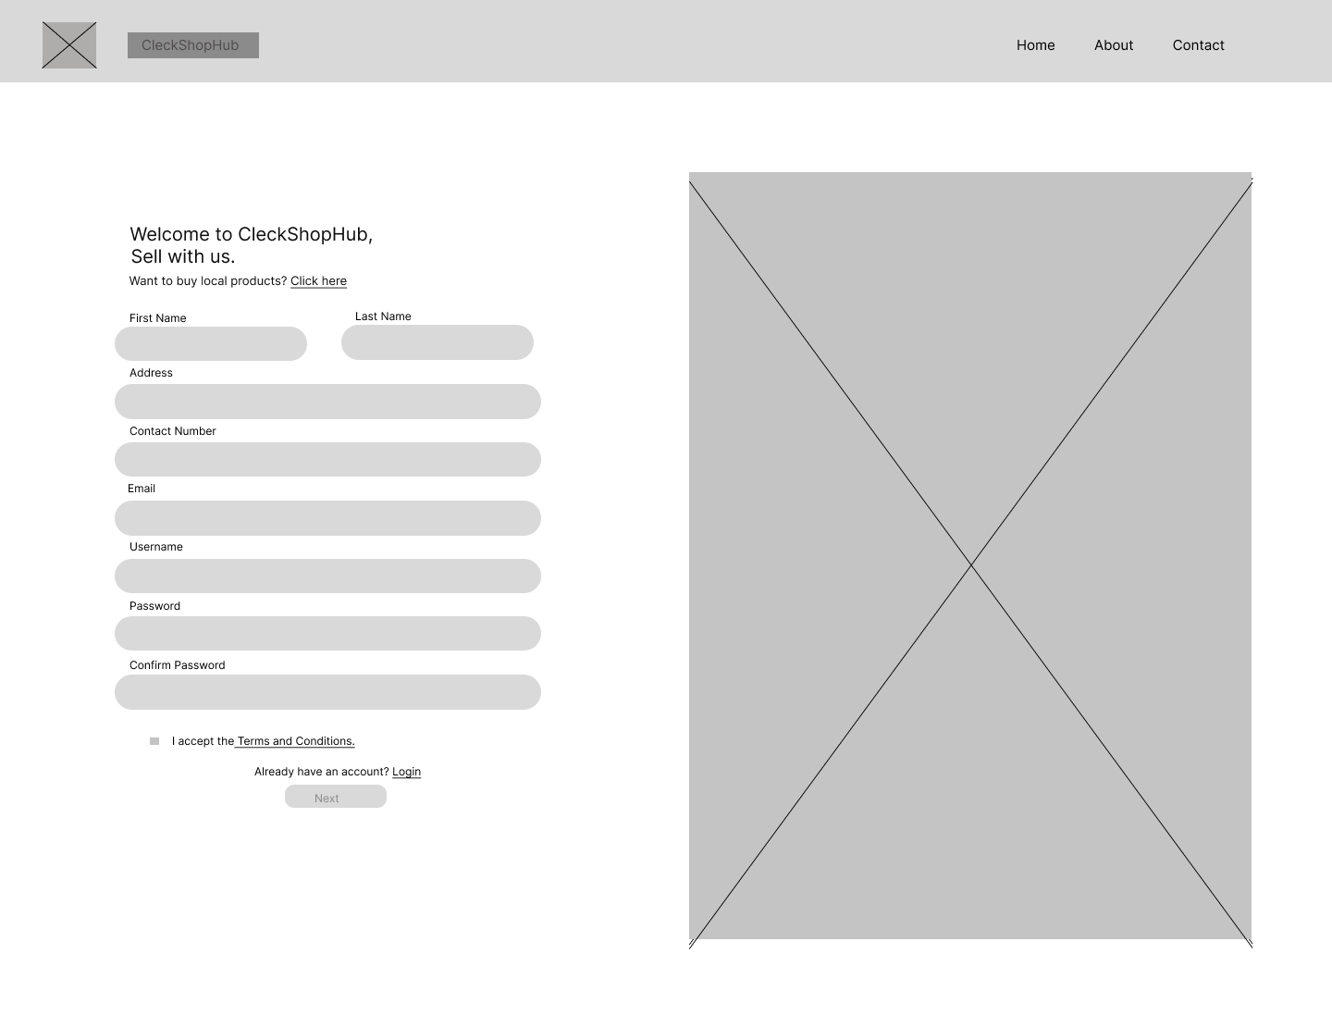

Figure : Register for Trader

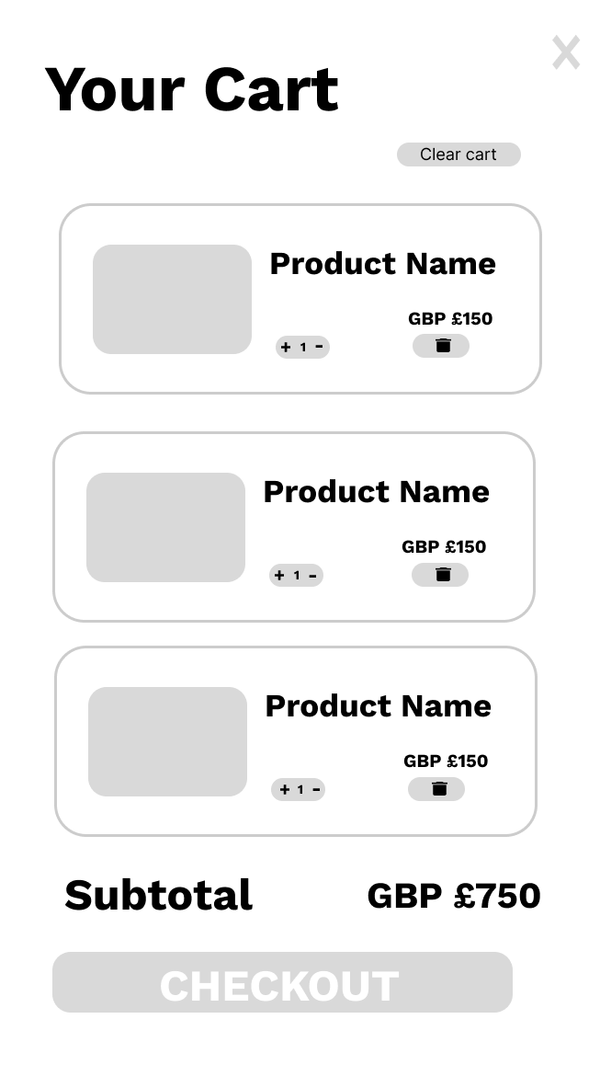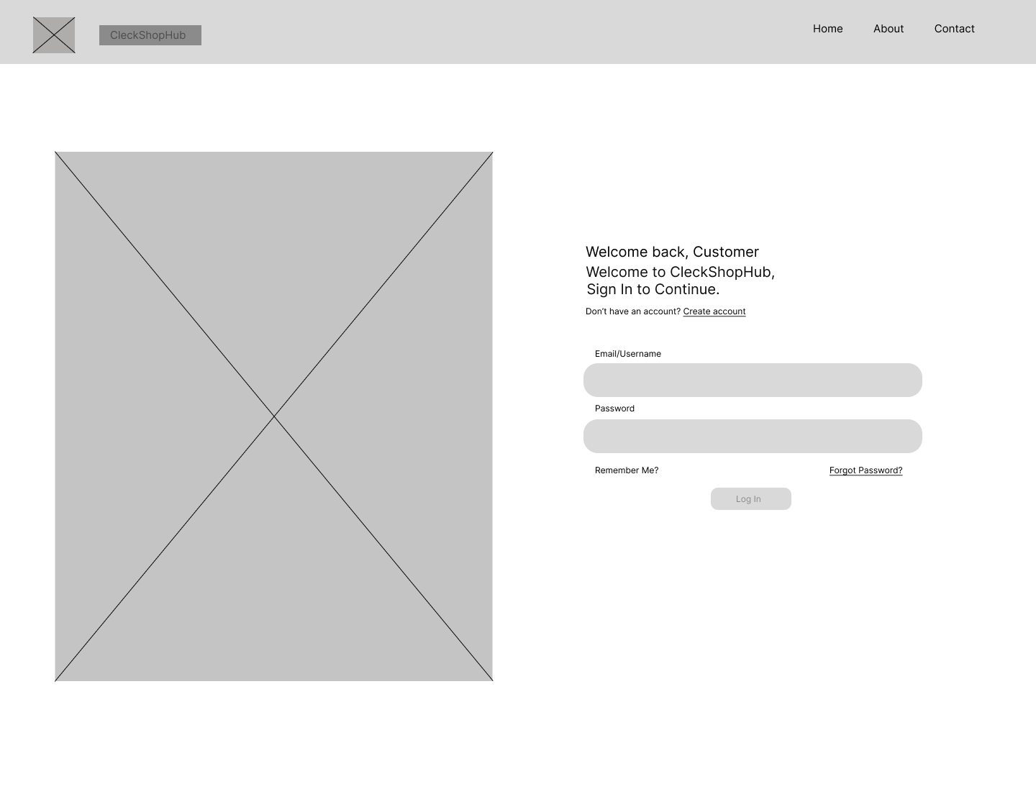

Figure 12: Cart

Figure 11: Login

# 3. Product Development